
Diesel Back-Up Generator Population Grows Rapidly in the Bay Area and Southern California

Executive Summary

California hosts a largely hidden grid of dispersed diesel generators, the population of which is growing rapidly. In December 2018 there were 6,497 back-up generators (BUGs) with 3,810 megawatts (MW) of collective capacity in the Bay Area Air Quality Management District (BAAQMD). In 2021 – less than three years later – BUG deployment had reached 8,722 generators, reflecting 4,840 MW of capacity, a 34 percent jump in the back-up generator fleet.

Similarly, in 2020 there were 12,104 back-up generators totaling 2,697 MW of capacity in the South Coast Air Quality Management District (SCAQMD). Just a year later this population had grown to 14,785 BUGs, with 7,360 MW capacity, a 22 percent increase in the fleet.

Throughout the state larger generators are being deployed more rapidly. Nearly 90 percent of back-up generators located in the two air districts are diesel fueled.

Diesel generators tend to be located close to where people live, work, and attend school. They are a significant air pollution source, releasing greenhouse gases, particulate matter (PM), volatile organic compounds (VOCs), nitrous oxides (NOx), and sulfur dioxide (SO₂), which can create smog and exacerbate respiratory conditions, like asthma, chronic obstructive pulmonary disease, and lung cancer, especially for children and older adults.

Data on the number of hours that diesel generators operate is self-reported, with little regulatory scrutiny. The degree to which BUGs run is influenced by multiple factors, including wildfires, Public Safety Power Shut-offs (PSPS), severe weather, and potentially their use to arbitrage electricity prices and programs.

Overview
The risks of electricity outages caused by wildfires and efforts to manage them – particularly PSPS – has significantly increased over the past several years. In response, California’s population of backup generators has grown rapidly. An analysis of the number and characteristics of BUGs permitted in the Bay Area (i.e., Alameda, Contra Costa, Marin, Napa, San Francisco, San Mateo, Santa Clara, and Sonoma counties) and South Coast (i.e., Los Angeles, Orange, Riverside, and San Bernadino counties) air quality management districts found that the generator population jumped by 22 percent in South Coast over the last year, with 34 percent growth in less than three years in the Bay Area.

In 2021 the two districts were collectively home to 23,507 BUGs, with a capacity of 12.2 gigawatts (GW) or 87,223 MWh a year. California’s electricity grid has a capacity of roughly 80 GW; BUGs in the Bay Area and South Coast alone can generate about 15 percent of the entire grid.

Based on conservative estimates, BUG use in the two districts alone produces annual emissions of 86,899 metric tons of carbon dioxide (MTCO₂), roughly 20 MT of fine particulate matter, 62 MT of VOCs, and almost 1,000 MT of haze-inducing NO_{x}. This pollution, in turn, may trigger upwards of $136 million of health costs a year, due to increases in mortalities, heart attacks, hospital visits and other adverse consequences. Costs associated with the statewide fleet of BUGs are obviously much higher.

In California, BUGs are individually permitted by one of 35 air districts in which they are located. The cumulative magnitude is largely hidden; data from individual districts is not meaningfully aggregated or reported at the state level.

2021 BAAQMD BUGs Portfolio
There are at least 8,722 backup generators operating in BAAQMD. Collectively, these machines have an estimated capacity of 4.84 gigawatts; 91 percent are used principally to generate electricity. Most of these assets – 90 percent – are diesel gensets, with six percent fueled by natural gas, three percent by liquified petroleum gas (LPG), as shown in Table 1.

Table 1: BAAQMD BUGs Portfolio, June 2021
Fuel | Count | MW Size | MW Capacity | Operating Hours | MWh Generation
Diesel | 7,864 | 0.603 | 4,739.0 | 79,717 | 27,296
Gasoline | 19 | 0.086 | 1.6 | 73 | 4
Natural Gas | 495 | 0.125 | 61.8 | 13,335 | 1,068
Propane | 15 | 0.193 | 2.9 | 179 | 15
Biodiesel | 28 | 0.175 | 4.9 | 82 | 8
LPG | 300 | 0.086 | 25.8 | 23,874 | 1,726
Jet Fuel | 1 | 0.820 | 0.8 | 313 | 192
Total | 8,722 | 0.555 | 4,836.8 | 117,573 | 30,310

Reported use data suggest that altogether the BUGs emit at least 35,350 metric tons of carbon dioxide (CO₂) a year. The generators also produce criteria air pollutant emissions which adversely affect respiratory health: more than six MT of fine PM, 24 MT of volatile organic compounds, and in excess of 321 MT of haze-inducing NO_{x}. Criteria air pollutants have unpleasant public health impacts at much lower concentrations than CO₂, with the worst consequences generally visited on disadvantaged communities.

Table 2: Annual MT Emissions from the BAAQMD BUGs Fleet
Fuel | CO₂ | PM | Organics | NO_{X}
Diesel | 26,449.9 | 5.7 | 19.1 | 304.5
Gasoline | 2.8 | 0.0 | 0.0 | 0.0
Natural Gas | 796.8 | 0.1 | 3.0 | 7.3
Propane | 14.8 | 0.0 | 0.0 | 0.2
Biodiesel | 6.6 | 0.0 | 0.0 | 0.1
LPG | 7,839.5 | 0.2 | 2.2 | 8.0
Jet Fuel | 239.2 | 0.1 | 0.1 | 0.8
Total | 35,350 | 6 | 24 | 321

LOCATION OF BUGs
In 2014, more than 9.3 million Californians lived in communities that were identified as “disadvantaged” by the California Environmental Protection Agency (CalEPA) due to environmental conditions and community members’ vulnerability to a degraded ecosystem. CalEnviroScreen is a method to evaluate multiple pollution sources in a geographically defined area that accounts for the population’s sensitivity to pollution’s adverse effects. Percentiles reflect the relative environmental burden in a given census tract.

As show in the map below, seventeen percent of generators are located in communities highly vulnerable to pollution, classified as being in the 80th to 100th percentile in the CalEnviroScreen Fourth Assessment. Six percent are above the 90th percentile.

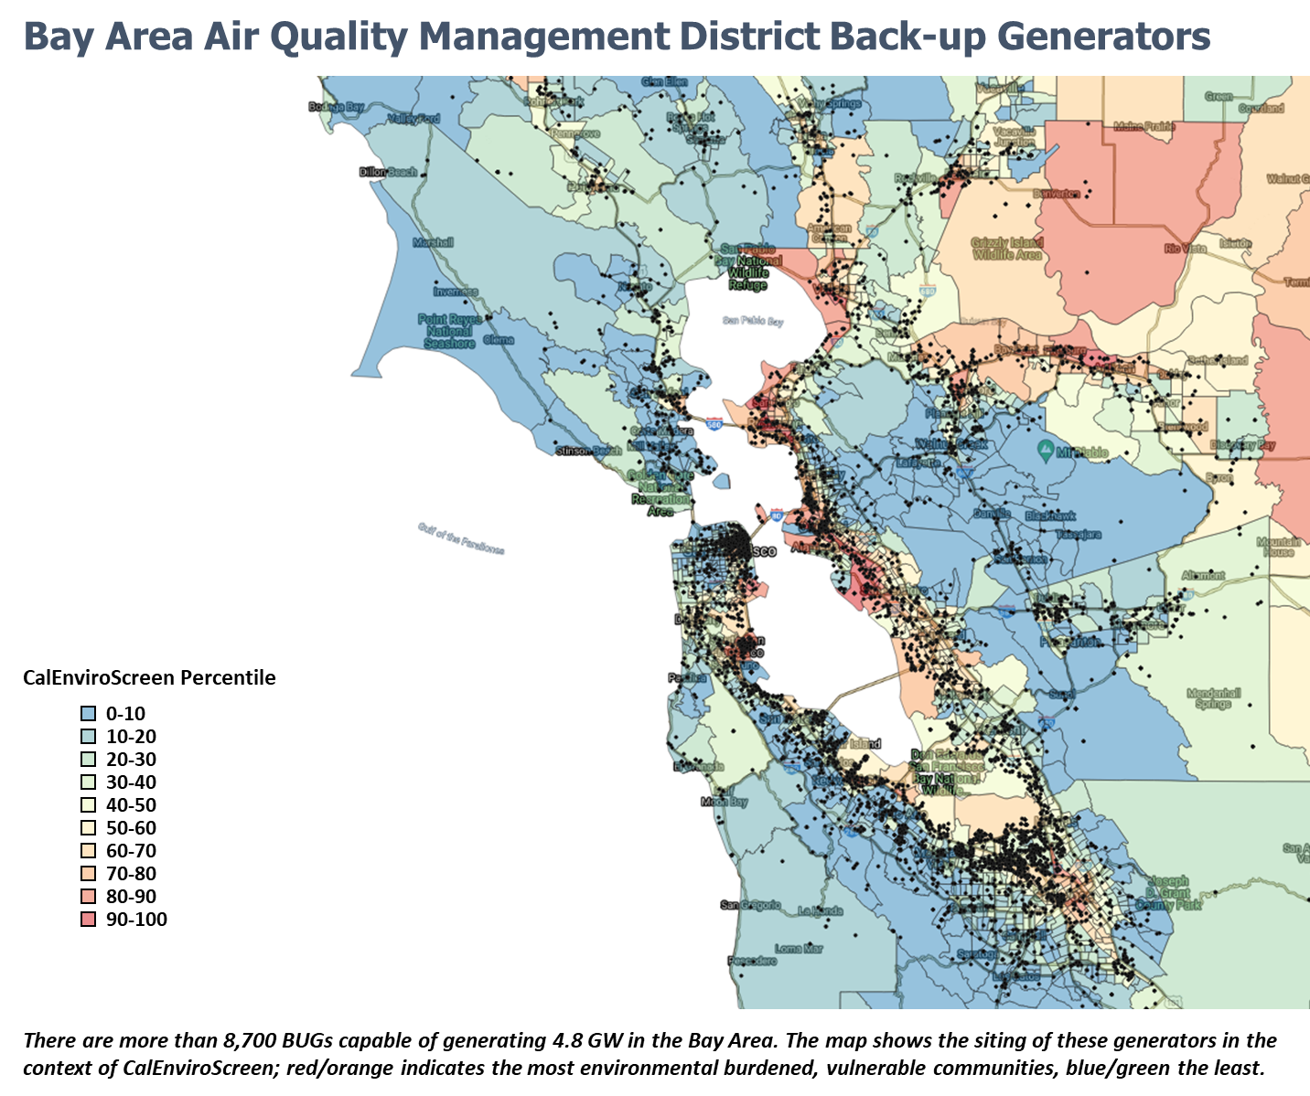
Figure 1: Map of BAAQMD BUGS

Compared to data collected in 2018, BUG population in the Bay Area has significantly expanded, growing from 6,497 to 8,722 today, a 34 percent jump. However, the two datasets do not compare perfectly. Assets were also analyzed based on the “Initial Permit Date” field using the most recent District dataset. This approach found that 518 assets with an estimated 270 MW of capacity have been newly permitted since April 2020, reflecting a more modest eight percent increase in the BUG population over the last year, as shown in Table 3. Given patterns exhibited in South Coast, as well as anecdotal evidence, it seems likely that the higher population increase estimate better reflects reality.

An additional 6,253 BUGs with 3.6 GW of capacity have renewed their permit since December 2018, as reflected in Table 4.

Table 3: Newly Permitted BUGS in BAAQMD since April 1, 2020
Fuel | Number | Average Size (MW) | Total Capacity (MW)
Diesel | 402 | 0.642 | 257.9
Gasoline | 0 | 0.000 | 0.0
Natural Gas | 48 | 0.121 | 5.8
Propane | 0 | 0.000 | 0.0
Biodiesel | 0 | 0.000 | 0.0
LPG | 68 | 0.092 | 6.3
Jet Fuel | 0 | 0.000 | 0.0
Total | 518 | 0.521 | 270.0

Table 4: Gensets with Permits Renewed after April 1, 2020
Fuel |  | Count | Average Size (MW) |  |  | Total Capacity (MW)
Diesel | 5,721 |  |  | 0.628 | 3,592.6
Gasoline | 12 |  |  | 0.094 | 1.1
Natural Gas | 301 |  |  | 0.123 | 37.1
Propane | 8 |  |  | 0.205 | 1.6
Biodiesel | 24 |  |  | 0.176 | 4.2
LPG | 186 |  |  | 0.090 | 16.7
Jet Fuel | 1 |  |  | 0.820 | 0.8
Total |  | 6,253 | 0.584 |  |  | 3,654.3

METHODOLOGY
A public records request for data on the universe of permitted backup gensets was filed with BAAQMD on March 17, 2021. Quality issues were identified in initial datasets provided; corrected information was transmitted on June 28, 2021. District data included facility information, locations, horsepower (HP), estimated emissions, and reported operating hours.

Reported runtimes and District-calculated emissions were utilized as the basis for estimates for most assets, with a few outlier observations dropped due to quality issues. In total, 11 assets reported annual operations that exceeded 8,760 hours. Another 156 BUGs included a statistical outlier for reported hours or calculated emissions per hour for CO₂, PM, organics, and NOx, which suggests potential issues with observations for those generators. Gensets with outlier data were included in overall count and capacity calculations, excluded from totals for hours, generation, and emissions estimates.

BUG owner/operators are required to report usage when their permits are renewed, but these data are not always reflected in the database. Altogether, 1,843 of the generators – 21 percent of the portfolio – last reported use to the District in 2018 or earlier despite being permitted for current operations. The population with missing data may be notably higher, as many facilities had blank or zero values for reporting date, which could indicate a new permit or a missing report.

2021 SCAQMD BUGs Portfolio
There are 14,785 backup generators operating in SCAQMD. Collectively, these generators have an estimated capacity of 7.36 gigawatts. Eighty-eight percent are diesel gensets, with 7.1 percent fueled by natural gas, as shown in Table 5.

Table 5: SCAQMD BUGs Portfolio, May 2021
Fuel | Count | Average Capacity (MW) | Capacity (MW) | Total Operation (Hours) | Estimated Generation (MWh)
Diesel | 13,043 | 0.543 | 7,085.6 | 134,474.3 | 54,789.9
LPG | 395 | 0.117 | 46.2 | 4,072.5 | 357.2
Natural Gas | 1,029 | 0.174 | 178.9 | 10,609.1 | 1,383.0
Oil | 97 | 0.198 | 19.2 | 1,000.1 | 148.7
Other fuel | 97 | 0.219 | 18.6 | 1,000.1 | 143.8
Gasoline | 105 | 0.096 | 8.9 | 1,082.6 | 68.5
Methanol | 19 | 0.150 | 2.8 | 195.9 | 22.0
Total | 14,785 | 0.498 | 7,360 | 152,434 | 56,913

Based on conservative use assumptions, this fleet has the potential to emit an estimated 51,549 metric tons of carbon dioxide a year. Further, the BUGs produce other criteria air pollutants on the order of 13.25 MT of fine particulate matter, 37.8 MT of volatile organic compounds, and 645.56 MT of NO_{x}.

Fuel | Emissions (MTCO₂) | Emissions MTPM | Emissions (MTOrg) | Emissions (MTNO_{x})
Diesel | 49,842 | 13.15 | 33.31 | 638.46
LPG | 355 | 0.01 | 0.22 | 0.50
Natural Gas | 1,004 | 0.06 | 3.76 | 3.95
Oil | 139 | 0.01 | 0.21 | 1.55
Other fuel | 134 | 0.01 | 0.14 | 0.63
Gasoline | 54 | 0.00 | 0.17 | 0.36
Methanol | 21 | 0.00 | 0.01 | 0.11
Total | 51,549 | 13.25 | 37.80 | 645.56

The map below shows the fleet of BUGs located in SCAQMD overlayed with CalEnviroScreen Fourth Assessment results., Forty-seven percent of generators are sited in communities classified as being in CalEnviroScreen’s 80th to 100th percentile; 33 percent are above the 90th percentile. These patterns are indicative of a BUG concentration in environmentally vulnerable communities in South Coast, but also reflect the incidence of above 80th percentile communities in the District more broadly.

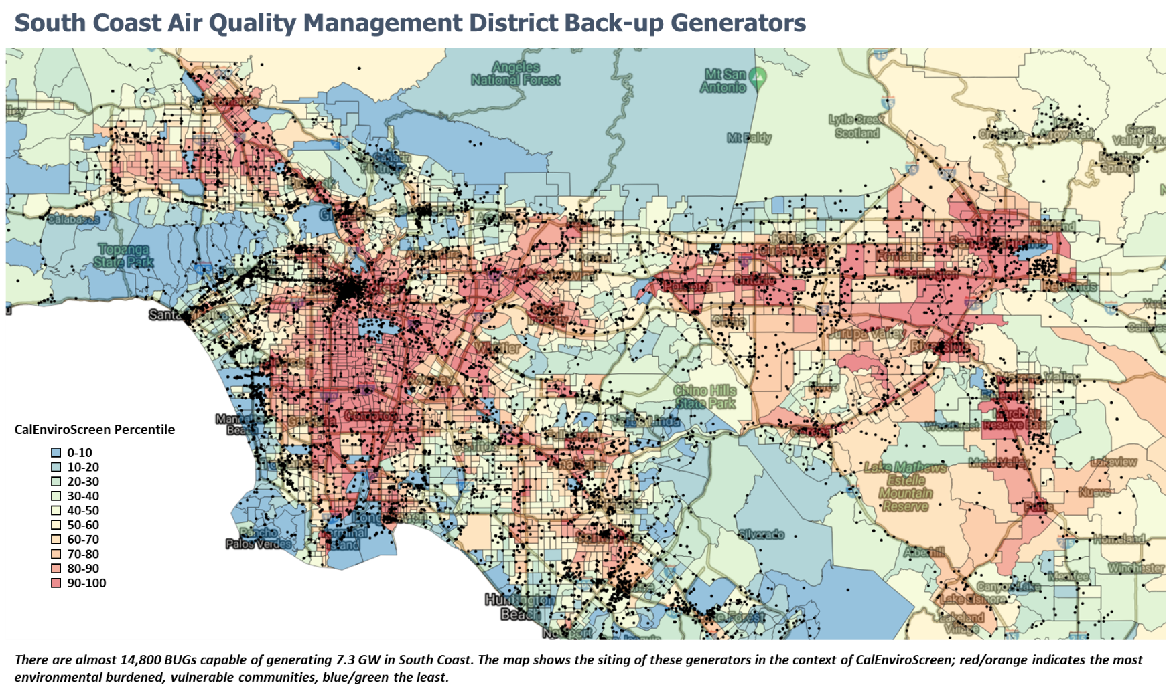
Figure 2: Map of SCAQMD BUGs

BUG population in South Coast has significantly expanded over the past year, growing from 12,104 in 2020 to 14,785 today, a 22 percent jump. This roughly matches with the new dataset, which indicates that 3,331 assets, with an estimated 1.66 GW of capacity have a “permit issue date” since April 1, 2020, a 23 percent increase. As reflected in the table below, the biggest rise was in diesel generators, 2,849, followed by natural gas, 239, and LPG, 147.

Table 6: BUGs permitted in SCAQMD since April 1, 2020
Fuel | Count of Assets | Average Capacity (MW) | Capacity (MW) | Total Operation (Hours) | Estimated Generation (MWh)
Diesel | 2,849 | 0.551 | 1,569.0 | 29,373.4 | 12,132.2
LPG | 147 | 0.139 | 20.4 | 1,515.6 | 157.7
Natural Gas | 239 | 0.227 | 54.3 | 2,464.1 | 419.9
Oil | 31 | 0.204 | 6.3 | 319.6 | 48.8
Other fuel | 38 | 0.230 | 7.6 | 391.8 | 58.6
Gasoline | 24 | 0.125 | 2.0 | 247.4 | 15.3
Methanol | 3 | 0.227 | 0.7 | 30.9 | 5.3
Total | 3,331 | 0.499 | 1,660 | 34,343 | 12,838

METHODOLOGY
A public records request was filed with SCAQMD on March 17, 2021 to obtain information on the universe of permitted gensets. Data was provided on May 14, 2021. SCAQMD only reported general descriptions for generator sizes (i.e., 50 to 500 horsepower, greater than 500 horsepower, and emergency generators). Different size classifications were assigned a HP value based on averages from the genset portfolio located in the Bay Area Air Quality Management District, as shown in Table 7 below. Horsepower figures were converted to estimated MW capacity by multiplying by 0.7457 and dividing by 1000.

Operating hours and emissions rates were also estimated based on averages from the BAAQMD portfolio. To account for the outliers described above, median data by fuel type were utilized. The accuracy of relying on assumptions derived from the Bay Area is unknown. Differences in outage rates, particularly related to Public Safety Power Shutoffs, risk perceptions, and risk tolerances, especially associated with the reliability needs of distinct economic segments, could influence BUG population and operating characteristics.

Table 7: Average HP, Operating Hours, and Emissions for SCAAMD based on BAAQMD Portfolio
Fuel | HP Class | Average Horsepower | Operating Hours | CO₂ MT/MWh | PM mt/MWh | Organics mt/MWh | NO_{x} mt/MWh
Diesel | 50-500 HP | 218.3 | 10.3 | 0.906 | 0.000240 | 0.000608 | 0.011653
Diesel | >500 HP | 1618.7 | 10.3 | 0.911 | 0.000240 | 0.000608 | 0.011653
Gasoline | 50-500 HP | 115.4 | 4.3 | 0.795 | 0.000055 | 0.003102 | 0.006798
Gasoline | >500 HP | 0.0 | 4.3 | 0.795 | 0.000055 | 0.003102 | 0.006798
Natural Gas | 50-500 HP | 124.8 | 27.7 | 0.726 | 0.000059 | 0.003907 | 0.004100
Natural Gas | >500 HP | 1102.0 | 27.7 | 0.726 | 0.000059 | 0.003907 | 0.004100
Oil | 50-500 HP | 98.5 | 11.9 | 0.932 | 0.000066 | 0.002069 | 0.015510
Oil | >500 HP | 700.0 | 11.9 | 0.932 | 0.000066 | 0.002069 | 0.015510
Methanol | 50-500 HP | 153.1 | 3.1 | 0.936 | 0.000225 | 0.000322 | 0.006797
Methanol | >500 HP | 606.4 | 3.1 | 0.936 | 0.000225 | 0.000322 | 0.006797
LPG | 50-500 HP | 111.6 | 85.3 | 0.993 | 0.000073 | 0.001088 | 0.002502
LPG | >500 HP | 687.5 | 85.3 | 0.993 | 0.000073 | 0.001088 | 0.002502
Jet Fuel | 50-500 HP | 0.0 | 312.6 | 1.244 | 0.000295 | 0.000328 | 0.004009
Jet Fuel | >500 HP | 1100.0 | 312.6 | 1.244 | 0.000295 | 0.000328 | 0.004009
Diesel | Emergency | 2220.0 | 2.4 | 0.911 | 0.000240 | 0.000608 | 0.011653
Other fuel | 50-500 HP | 117.4 | 65.0 | 0.933 | 0.000145 | 0.001632 | 0.007338
Other fuel | >500 HP | 830.7 | 65.0 | 0.934 | 0.000145 | 0.001632 | 0.007338

HEALTH AND ECONOMIC IMPLICATIONS
Particulate matter, volatile organics, and NOx emissions from back-up generators induce adverse health and economic impacts. These effects were examined using the U.S. Environmental Protection Agency’s CO-Benefits Risk Assessment Health Impacts Screening and Mapping Tool (COBRA), an analytical instrument crafted to estimate air quality and health consequences of different emission scenarios. COBRA approximates the influence polluting air has on mortality, hospital admissions, respiration, work loss, and the like, and associates a monetary value to those elements.
The simplified web-based COBRA tool was utilized to develop order of magnitude estimates of potential health and economic benefits of reducing PM, volatile organics, and NOx emissions from BUGs located in the Bay Area and South Coast. Estimated annual pollutant emissions from the two districts are summarized in the table below.

Table 8: PM, VOC, and NOx emissions from BUGs in the Bay Area and South Coast
District | PM, MT | Organics, MT | NO_{X}, MT
BAAQMD | 6 | 24 | 321
SCAQMD | 13 | 38 | 646
COBRA projects emissions for PM, SO₂, NO_{x}, Ammonia (NH₃), and VOC based on economic sectors and subsectors in selected geographies. No sector precisely matches with “back-up generation.” Given that BUGs in the districts are mostly commercially owned and more than 90 percent diesel powered, the closest sector is “Fuel Combustion: Industrial,” with the sub-sector “Internal Combustion.” However, baseline emissions in this subsector are below those estimated for the BUGs fleet, prompting the use of “All sub-sectors.”
To illustrate the impact of phasing out BUGs – or, conversely, the harms caused by their present use – as well as capture uncertainties in underlying BUG emission estimates, collective reductions for PM, NO_{x}, and volatile organics of 25 percent, 50 percent, and 100 percent were modeled. COBRA outputs for 25 percent and 100 percent reductions in Bay Area counties are shown in Figure 3 below. Overall, the economic benefits of reducing BUG emissions range from $3.5 to $7.9 million annually for a 25 percent reduction, $7 to $15.9 million for a 50 percent reduction, and $14.1 to $31.8 million for 100 percent.
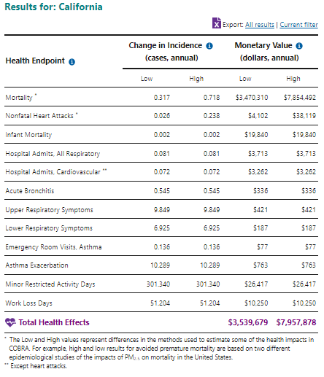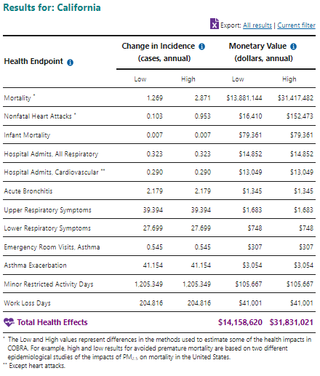
Figure 3: COBRA Outputs for 25 percent (left) and 100 percent reduction (right) in PM, VOC, and NOx emissions in Bay Area counties
The COBRA outputs for reducing 25 percent, 50 percent, and 100 percent of BUG emissions in South Coast counties are shown in Figure 4 below. Overall, the economic benefits of reducing BUG pollution range from $11.5 to $25.9 million annually for a 25 percent reduction, $23.1 to $51.9 million for a 50 percent reduction, and $46.2 to $103.9 million a year for a 100 percent reduction.
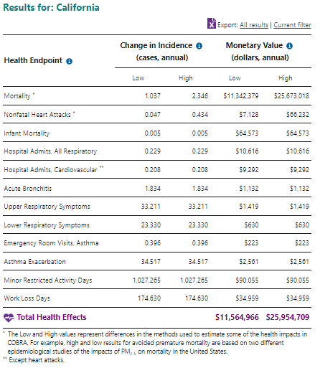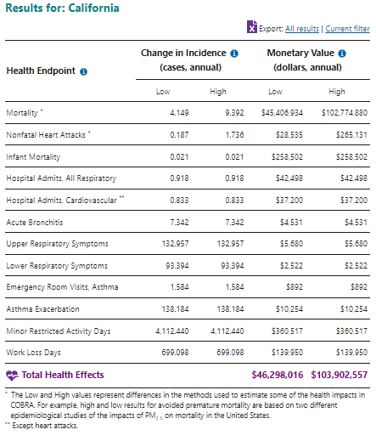
Figure 3: COBRA Outputs for 25 percent (left) and 100 percent reduction (right) in PM, VOC, and NOx emissions in South Coast counties
DISTRICT DATA ISSUES
It is challenging to secure comprehensive, reliable, data from the districts. The Public Records Request process can take several months and may not yield dependable or actionable information. For example, the initial Public Records Request fulfilled by BAAQMD had numerous data quality issues, including negative and impossible usage values (e.g., greater than 8,760 hours for a year), as well as use levels that did not match permitted values. The dataset exhibited incompatible units and labels, complicating portfolio level analyses. According to the District, inconsistencies between different vintage databases caused most of the errors.

BUG usage data is self-reported by the facilities themselves. BUG operators are supposed to describe use when their permits are renewed, but this information is not always reflected in the database. Altogether, 1,843 of the generators – 21 percent of the portfolio – last reported usage to BAAQMD in 2018 or earlier despite being permitted for current operations. What’s more, 23 percent of the BUGs conveyed operational hours that were higher than their permit allowed. It is unclear whether these discrepancies reflect actual higher use, missing reports, data quality issues or problems with the database itself.

SCAQMD does not provide data on generator size, instead reporting BUGs as “50-500 horsepower”, “>500 horsepower”, or “emergency generator,” nor does South Coast deliver usage or emissions calculations for their BUGs portfolio. Data access and quality challenges in the state’s two largest air quality districts are likely replicated in the rest of the districts.

Diesel-powered BUGs potentially represent a substantial hurdle to achieving greenhouse gas goals, and likely contribute to localized public health harms associated with pollution, particularly in vulnerable communities. Giving the large and growing generator population and its potential to adversely impact public health it is critical to have confidence in underlying deployment and use data. Information should be easily accessible and comparable across the districts and include estimated usage and emissions. Resulting data streams should be integrated into the State’s ongoing climate and clean energy planning.

Annex 1: Count of BUGs by City in BAAQMD
City | Dec-18 | Jun-20 | Increase | City | Dec-18 | Jun-20 | Increase
Alameda | 42 | 58 | 16 | Millbrae | 21 | 24 | 3
Alamo | 2 | 3 | 1 | Milpitas | 72 | 117 | 45
Albany | 14 | 16 | 2 | Moffett Field | 10 | 10 | 0
Alviso | 4 | 7 | 3 | Montara | 4 | 4 | 0
Amer. Canyon | 13 | 20 | 7 | Moraga | 8 | 10 | 2
Angwin | 5 | 10 | 5 | Morgan Hill | 32 | 35 | 3
Antioch | 42 | 49 | 7 | Moss Beach | 3 | 4 | 1
Atherton | 12 | 23 | 11 | Mount. View | 142 | 192 | 50
Bay Point | 1 | 2 | 1 | Muir Beach | 0 | 1 | 1
Belmont | 25 | 27 | 2 | Napa | 92 | 156 | 64
Belvedere | 0 | 2 | 2 | Newark | 47 | 58 | 11
Benicia | 22 | 35 | 13 | Nicasio | 4 | 4 | 0
Berkeley | 131 | 149 | 18 | Novato | 59 | 74 | 15
Bethel Island | 2 | 6 | 4 | Oakland | 229 | 348 | 119
Birds Land. | 1 | 1 | 0 | Oakley | 18 | 21 | 3
Bolinas | 4 | 4 | 0 | Oakville | 3 | 11 | 8
Brentwood | 23 | 27 | 4 | Orinda | 14 | 16 | 2
Brisbane | 22 | 31 | 9 | Pacheco | 2 | 3 | 1
Burlingame | 50 | 68 | 18 | Pacifica | 11 | 18 | 7
Byron | 13 | 17 | 4 | Palo Alto | 203 | 231 | 28
Calistoga | 19 | 42 | 23 | Penngrove | 0 | 1 | 1
Campbell | 18 | 24 | 6 | Pescadero | 3 | 3 | 0
Castro Valley | 20 | 22 | 2 | Petaluma | 50 | 65 | 15
Clayton | 10 | 11 | 1 | Pinole | 11 | 14 | 3
Colma | 5 | 7 | 2 | Pittsburg | 52 | 62 | 10
Concord | 100 | 118 | 18 | Pleasant Hill | 16 | 17 | 1
Corte Madera | 8 | 8 | 0 | Pleasanton | 65 | 78 | 13
Cotati | 3 | 3 | 0 | Point Reyes | 4 | 4 | 0
Coyote | 1 | 4 | 3 | Pope Valley | 1 | 3 | 2
Crockett | 7 | 13 | 6 | Portola Val. | 4 | 7 | 3
Cupertino | 63 | 70 | 7 | Redwood Cit. | 147 | 190 | 43
Daly City | 49 | 53 | 4 | Richmond | 69 | 129 | 60
Danville | 12 | 14 | 2 | Rodeo | 4 | 13 | 9
Deer Park | 0 | 1 | 1 | Rohnert Park | 26 | 30 | 4
Dillon Beach | 1 | 1 | 0 | Ross | 1 | 2 | 1
Discovery Bay | 8 | 8 | 0 | Rutherford | 7 | 13 | 6
Dublin | 40 | 47 | 7 | Saint Helena | 27 | 84 | 57
East Palo Alto | 10 | 10 | 0 | San Anselmo | 2 | 5 | 3
El Cerrito | 7 | 10 | 3 | San Bruno | 33 | 43 | 10
El Granada | 2 | 3 | 1 | San Carlos | 35 | 46 | 11
El Sobrante | 3 | 3 | 0 | San Francisco | 841 | 1190 | 349
El Verano | 1 | 1 | 0 | S. Geronimo | 1 | 1 | 0
Eldridge | 5 | 5 | 0 | San Gregorio | 1 | 1 | 0
Emeryville | 46 | 59 | 13 | San Jose | 589 | 772 | 183
Fairfax | 1 | 1 | 0 | San Leandro | 61 | 73 | 12
Fairfield | 97 | 138 | 41 | San Lorenzo | 11 | 20 | 9
Forest Knolls | 1 | 1 | 0 | San Martin | 8 | 9 | 1
FORESTVILLE | 1 | 1 | 0 | San Mateo | 76 | 110 | 34
Foster City | 45 | 74 | 29 | San Pablo | 3 | 6 | 3
Freestone | 1 | 2 | 1 | San Quentin | 4 | 10 | 6
Fremont | 148 | 203 | 55 | San Rafael | 73 | 98 | 25
Fulton | 1 | 1 | 0 | San Ramon | 45 | 47 | 2
Gilroy | 60 | 76 | 16 | Santa Clara | 515 | 668 | 153
Glen Ellen | 2 | 8 | 6 | Santa Rosa | 143 | 192 | 49
Greenbrae | 3 | 8 | 5 | Saratoga | 14 | 14 | 0
Half Moon By | 26 | 25 | -1 | Sausalito | 19 | 22 | 3
Hayward | 140 | 179 | 39 | Sebastopol | 13 | 22 | 9
Healdsburg | 1 | 1 | 0 | Sonoma | 20 | 45 | 25
Hercules | 17 | 18 | 1 | S. San Fran. | 151 | 202 | 51
Hillsborough | 3 | 6 | 3 | Stanford | 15 | 20 | 5
Hollister | 3 | 4 | 1 | Stinson Bea. | 1 | 3 | 2
Inverness | 0 | 1 | 1 | Suisun City | 16 | 24 | 8
Kensington | 2 | 3 | 1 | Sunnyvale | 219 | 274 | 55
Kentfield | 1 | 3 | 2 | Sunol | 13 | 19 | 6
Kenwood | 3 | 10 | 7 | Tiburon | 16 | 23 | 7
La Honda | 5 | 6 | 1 | Tomales | 2 | 3 | 1
Lafayette | 5 | 6 | 1 | Tracy | 1 | 1 | 0
Lagunitas | 1 | 1 | 0 | Travis AFB | 45 | 59 | 14
Larkspur | 6 | 6 | 0 | Union City | 36 | 48 | 12
Livermore | 150 | 176 | 26 | Vacaville | 0 | 1 | 1
Loma Mar | 0 | 2 | 2 | Vallejo | 62 | 72 | 10
Los Altos | 18 | 23 | 5 | Valley Ford | 1 | 1 | 0
Los Altos Hills | 8 | 10 | 2 | Walnut Creek | 79 | 103 | 24
Los Gatos | 46 | 55 | 9 | Windsor | 14 | 18 | 4
Martinez | 63 | 98 | 35 | Woodacre | 2 | 2 | 0
Menlo Park | 88 | 101 | 13 | Woodside | 8 | 14 | 6
Mill Valley | 23 | 29 | 6 | Yountville | 12 | 21 | 9

Annex 2: Count of BUGs by City in SCAQMD
City | Apr-20 | May-21 | Change | City | Apr-20 | May-21 | Change
ACTON | 4 | 3 | -1 | LYNWOOD | 15 | 21 | 6
AGOURA | 4 | 4 | 0 | LYTLE CREEK | 3 | 3 | 0
AGOURA HILLS | 10 | 16 | 6 | MALIBU | 49 | 56 | 7
AGUA DULCE | 2 | 2 | 0 | MANHATTAN BEACH | 25 | 31 | 6
AGUANGA | 3 | 4 | 1 | March Air Reserve B. | 10 | 7 | -3
ALHAMBRA | 51 | 63 | 12 | MARINA DEL REY | 30 | 33 | 3
ALISO VIEJO | 39 | 47 | 8 | MAYWOOD | 3 | 4 | 1
ALTA LOMA | 1 | 2 | 1 | MECCA | 8 | 9 | 1
ALTADENA | 14 | 14 | 0 | MENIFEE | 17 | 22 | 5
ANAHEIM | 263 | 299 | 36 | MENTONE | 3 | 3 | 0
ANAHEIM HILLS | 2 | 2 | 0 | MIDWAY CITY | 1 | 1 | 0
ANGELUS OAKS | 1 | 1 | 0 | MIRA LOMA | 37 | 47 | 10
ANZA | 8 | 11 | 3 | MISSION HILLS | 10 | 10 | 0
APPLE VALLEY | 0 | 2 | 2 | MISSION VIEJO | 58 | 64 | 6
ARCADIA | 50 | 62 | 12 | MONROVIA | 30 | 31 | 1
ARLETA | 3 | 3 | 0 | MONTCLAIR | 17 | 17 | 0
ARLINGTON | 1 | 1 | 0 | MONTEBELLO | 40 | 47 | 7
Arrowbear Lake | 4 | 6 | 2 | MONTEREY PARK | 49 | 63 | 14
ARTESIA | 3 | 5 | 2 | MONTROSE | 1 | 3 | 2
AVALON | 15 | 27 | 12 | MORENO VALLEY | 91 | 116 | 25
AZUSA | 46 | 51 | 5 | MOUNT WILSON | 26 | 32 | 6
BAKER | 0 | 1 | 1 | MOUNTAIN CENTER | 6 | 7 | 1
BALDWIN PARK | 28 | 34 | 6 | Mount Baldy | 1 | 4 | 3
BANNING | 33 | 41 | 8 | MURRIETA | 62 | 75 | 13
BARSTOW | 0 | 1 | 1 | Murrieta Hot Springs | 1 | 3 | 2
BEAUMONT | 36 | 42 | 6 | MUSCOY | 1 | 1 | 0
BELL | 7 | 8 | 1 | North Hollywood | 1 | 1 | 0
BELL GARDENS | 11 | 12 | 1 | NEEDLES | 0 | 2 | 2
BELLFLOWER | 18 | 23 | 5 | NEWBURY PARK | 0 | 1 | 1
Bermuda Dunes | 5 | 5 | 0 | NEWHALL | 7 | 10 | 3
BEVERLY HILLS | 119 | 132 | 13 | NEWPORT BEACH | 123 | 135 | 12
BIG BEAR | 2 | 3 | 1 | NEWPORT COAST | 5 | 6 | 1
BIG BEAR CITY | 16 | 19 | 3 | NILAND | 1 | 1 | 0
BIG BEAR LAKE | 49 | 70 | 21 | NORCO | 15 | 23 | 8
BLOOMINGTON | 24 | 32 | 8 | NORTH HILLS | 9 | 12 | 3
BLUE JAY | 6 | 8 | 2 | NORTH HOLLYWOOD | 38 | 44 | 6
BLYTHE | 1 | 5 | 4 | North Palm Springs | 6 | 9 | 3
BRADBURY | 1 | 2 | 1 | NORTH SHORE | 1 | 1 | 0
BREA | 59 | 66 | 7 | NORTH TUSTIN | 1 | 3 | 2
BUENA PARK | 45 | 48 | 3 | NORTHRIDGE | 62 | 71 | 9
BURBANK | 161 | 176 | 15 | NORWALK | 44 | 60 | 16
CABAZON | 4 | 4 | 0 | NUEVO | 4 | 4 | 0
CALABASAS | 28 | 31 | 3 | ONTARIO | 170 | 190 | 20
CALIMESA | 4 | 4 | 0 | ORANGE | 136 | 138 | 2
CANOGA PARK | 32 | 35 | 3 | PACIFIC PALISADES | 12 | 13 | 1
CANYON COTRY | 4 | 5 | 1 | PACOIMA | 18 | 19 | 1
CANYON LAKE | 7 | 7 | 0 | PALM DESERT | 78 | 88 | 10
CAPISTRANO B. | 3 | 3 | 0 | PALM SPRINGS | 56 | 61 | 5
CARSON | 58 | 69 | 11 | PALMDALE | 0 | 6 | 6
CASTAIC | 31 | 61 | 30 | Palos Verdes Estates | 8 | 10 | 2
CATALINA | 2 | 1 | -1 | PANORAMA CITY | 18 | 19 | 1
Cathedral City | 16 | 17 | 1 | PARAMOUNT | 18 | 32 | 14
CEDAR GLEN | 6 | 6 | 0 | PASADENA | 213 | 246 | 33
CERRITOS | 40 | 48 | 8 | PERRIS | 71 | 93 | 22
CHATSWORTH | 33 | 48 | 15 | PICO RIVERA | 26 | 25 | -1
CHERRY VALLEY | 1 | 1 | 0 | PLACENTIA | 9 | 13 | 4
CHINO | 70 | 92 | 22 | PLAYA DEL REY | 15 | 28 | 13
CHINO HILLS | 32 | 33 | 1 | PLAYA VISTA | 13 | 13 | 0
Chiriaco Summit | 2 | 2 | 0 | POMONA | 84 | 97 | 13
City of Industry | 72 | 1 | -71 | PORTER RANCH | 2 | 2 | 0
CLAREMONT | 62 | 78 | 16 | QUAIL VALLEY | 4 | 4 | 0
COACHELLA | 19 | 27 | 8 | RANCHO CUCAMGA | 125 | 151 | 26
COLTON | 38 | 43 | 5 | RANCHO DOMIGUEZ | 8 | 9 | 1
COMMERCE | 43 | 52 | 9 | RANCHO MIRAGE | 41 | 44 | 3
COMPTON | 36 | 43 | 7 | Rancho Mission Viejo | 3 | 3 | 0
CORONA | 137 | 157 | 20 | Rancho Palos Verdes | 22 | 22 | 0
Corona Del Mar | 5 | 4 | -1 | Rancho Santa Magar. | 29 | 29 | 0
COSTA MESA | 110 | 133 | 23 | REDLANDS | 110 | 128 | 18
COTO DE CAZA | 3 | 3 | 0 | REDONDO BEACH | 78 | 85 | 7
COVINA | 27 | 30 | 3 | RESEDA | 14 | 17 | 3
CREST PARK | 1 | 1 | 0 | RIALTO | 69 | 83 | 14
CRESTLINE | 22 | 24 | 2 | RIMFOREST | 1 | 1 | 0
CUDAHY | 4 | 6 | 2 | RIVERSIDE | 339 | 387 | 48
CULVER CITY | 76 | 85 | 9 | RIVERSIDE | 1 | 3 | 2
CYPRESS | 31 | 36 | 5 | ROLLING HILLS | 2 | 1 | -1
DANA POINT | 18 | 21 | 3 | Rolling Hills Estates | 8 | 9 | 1
DESERT CENTER | 16 | 24 | 8 | ROMOLAND | 4 | 4 | 0
Desert Hot Spri. | 27 | 38 | 11 | ROSEMEAD | 23 | 29 | 6
Devore Heights | 2 | 2 | 0 | ROWLAND HEIGHTS | 7 | 7 | 0
DIAMOND BAR | 28 | 575 | 547 | RUBIDOUX | 9 | 9 | 0
DOWNEY | 53 | 67 | 14 | RUNNING SPRINGS | 37 | 35 | -2
DUARTE | 15 | 19 | 4 | SAN BERNARDINO | 210 | 252 | 42
EAGLE ROCK | 3 | 3 | 0 | SAN CLEMENTE | 57 | 81 | 24
East Los Angeles | 3 | 3 | 0 | SAN DIMAS | 43 | 46 | 3
EASTVALE | 12 | 14 | 2 | SAN FERNANDO | 8 | 9 | 1
EL MONTE | 40 | 46 | 6 | SAN GABRIEL | 14 | 14 | 0
EL SEGUNDO | 167 | 189 | 22 | SAN JACINTO | 26 | 33 | 7
EL TORO | 7 | 7 | 0 | San Juan Capistrano | 37 | 40 | 3
ENCINO | 33 | 35 | 2 | SAN MARINO | 13 | 14 | 1
ESCONDIDO | 0 | 1 | 1 | SAN PEDRO | 59 | 68 | 9
ETIWANDA | 3 | 3 | 0 | SANTA ANA | 165 | 208 | 43
FAWNSKIN | 6 | 8 | 2 | SANTA CLARITA | 57 | 65 | 8
FONTANA | 134 | 152 | 18 | SANTA FE SPRINGS | 55 | 66 | 11
Foothill Ranch | 11 | 14 | 3 | SANTA MONICA | 135 | 140 | 5
FOREST FALLS | 4 | 4 | 0 | SAUGUS | 14 | 10 | -4
FOUNTAIN VALY | 46 | 61 | 15 | SEAL BEACH | 49 | 63 | 14
FULLERTON | 90 | 105 | 15 | SEPULVEDA | 2 | 3 | 1
GARDEN GROVE | 44 | 44 | 0 | SHERMAN OAKS | 35 | 34 | -1
GARDENA | 51 | 60 | 9 | SIERRA MADRE | 7 | 8 | 1
GLENDALE | 139 | 169 | 30 | SIGNAL HILL | 13 | 18 | 5
GLENDORA | 28 | 30 | 2 | SILVERADO | 14 | 16 | 2
GORMAN | 12 | 12 | 0 | SOUTH EL MONTE | 9 | 12 | 3
GRANADA HILLS | 12 | 16 | 4 | SOUTH GATE | 23 | 30 | 7
Grand Terrace | 5 | 5 | 0 | SOUTH PASADENA | 4 | 6 | 2
GREEN VALLEY | 1 | 1 | 0 | STANTON | 11 | 14 | 3
Green Valley La. | 4 | 4 | 0 | STEVENSON RANCH | 2 | 3 | 1
Hacienda Heigh. | 12 | 12 | 0 | STUDIO CITY | 18 | 10 | -8
HARBOR CITY | 8 | 11 | 3 | SUGARLOAF | 1 | 1 | 0
Hawaiian Gard. | 4 | 4 | 0 | SUN CITY | 11 | 10 | -1
HAWTHORNE | 35 | 38 | 3 | SUN VALLEY | 28 | 33 | 5
HEMET | 56 | 71 | 15 | SUNLAND | 4 | 4 | 0
Hermosa Beach | 8 | 9 | 1 | SYLMAR | 49 | 59 | 10
HESPERIA | 1 | 1 | 0 | TARZANA | 14 | 18 | 4
HIDDEN HILLS | 2 | 2 | 0 | TEMECULA | 87 | 109 | 22
HIGHLAND | 24 | 24 | 0 | TEMESCAL VALLEY | 1 | 1 | 0
HOLLYWOOD | 29 | 30 | 1 | TEMPLE CITY | 6 | 8 | 2
HOMELAND | 3 | 5 | 2 | TERMINAL ISLAND | 5 | 7 | 2
Huntington Bea. | 128 | 163 | 35 | THERMAL | 17 | 19 | 2
Huntington Park | 17 | 20 | 3 | THOUSAND OAKS | 0 | 2 | 2
IDYLLWILD | 9 | 9 | 0 | THOUSAND PALMS | 8 | 8 | 0
INDIAN WELLS | 14 | 15 | 1 | TOLUCA LAKE | 1 | 1 | 0
INDIO | 65 | 67 | 2 | TOPANGA | 2 | 2 | 0
INGLEWOOD | 44 | 54 | 10 | TORRANCE | 161 | 174 | 13
IRVINE | 445 | 489 | 44 | TRABUCO CANYON | 17 | 18 | 1
IRWINDALE | 28 | 38 | 10 | TUJUNGA | 6 | 9 | 3
JOSHUA TREE | 0 | 1 | 1 | TUSTIN | 40 | 46 | 6
JURUPA | 1 | 1 | 0 | TWIN PEAKS | 4 | 6 | 2
JURUPA VALLEY | 5 | 8 | 3 | UNIVERSAL CITY | 42 | 54 | 12
LA CANADA | 9 | 7 | -2 | UPLAND | 28 | 31 | 3
LA CANADA FLIE | 20 | 28 | 8 | VAL VERDE | 1 | 1 | 0
LA CRESCENTA | 10 | 10 | 0 | VALENCIA | 60 | 68 | 8
LA HABRA | 21 | 23 | 2 | VALLEY VILLAGE | 2 | 2 | 0
LA MIRADA | 23 | 27 | 4 | VAN NUYS | 69 | 85 | 16
LA PALMA | 13 | 14 | 1 | VENICE | 7 | 8 | 1
LA PUENTE | 11 | 14 | 3 | VENTURA | 0 | 1 | 1
LA QUINTA | 38 | 45 | 7 | VERNON | 30 | 37 | 7
LA VERNE | 19 | 24 | 5 | VIEW PARK | 0 | 1 | 1
LADERA RANCH | 5 | 6 | 1 | VILLA PARK | 1 | 1 | 0
LAGUNA BEACH | 40 | 44 | 4 | WALNUT | 22 | 28 | 6
LAGUNA HILLS | 30 | 36 | 6 | WALNUT PARK | 1 | 1 | 0
LAGUNA NIGUL | 39 | 40 | 1 | WATTS | 1 | 1 | 0
Laguna Woods | 8 | 10 | 2 | WEST COVINA | 40 | 44 | 4
Lake Arrowhead | 31 | 32 | 1 | WEST HILLS | 12 | 10 | -2
LAKE ELSINORE | 52 | 58 | 6 | WEST HOLLYWOOD | 41 | 41 | 0
LAKE FOREST | 28 | 28 | 0 | WEST LOS ANGELES | 5 | 4 | -1
LAKE HUGHES | 2 | 5 | 3 | WESTCHESTER | 3 | 3 | 0
Lake View Terr. | 3 | 3 | 0 | WESTLAKE VILLAGE | 27 | 27 | 0
LAKEVIEW | 1 | 1 | 0 | WESTMINSTER | 27 | 34 | 7
LAKEWOOD | 26 | 33 | 7 | WHITE WATER | 1 | 0 | -1
LANCASTER | 0 | 3 | 3 | WHITTIER | 64 | 73 | 9
LAWNDALE | 6 | 6 | 0 | WILDOMAR | 17 | 16 | -1
LEBEC | 3 | 1 | -2 | WILMINGTON | 56 | 73 | 17
LOMA LINDA | 33 | 34 | 1 | WINCHESTER | 15 | 16 | 1
LOMITA | 5 | 6 | 1 | WOODLAND HILLS | 70 | 67 | -3
LONG BEACH | 316 | 396 | 80 | WRIGHTWOOD | 0 | 2 | 2
LOS ALAMITOS | 24 | 30 | 6 | YORBA LINDA | 31 | 37 | 6
LOS ANGELES | 2,100 | 2,463 | 363 | YUCAIPA | 25 | 27 | 2

This survey is a continuation of work by Steven Moss, M.Cubed Partner and Andy Bilich, Research Associate, http://www.lgsec.org/wp-content/uploads/2020/05/BUGs-in-5-CA-Air-Districts.pdf, which was updated at the request of Bloom Energy. Steven@moss.net, 415.643.9578, www.mcubed-econ.com
Data discrepancies are noted in the report; estimates are based on best available information.
Informal conversations with air district staff suggest that higher capacity gensets are being deployed, in part to safeguard reliability at data centers and other large facilities. Likewise, investor-owned utilities and local governments have been fielding large gensets as part of wildfire resiliency-related efforts.
Based on data obtained from the districts in May and June 2021.
Based on U.S. Environmental Protection Agency’s CO-Benefits Risk Assessment Health Impacts Screening and Mapping Tool.
An analysis published in 2020 found a total of 18,600 BUGs in the two air districts, with 6.5 GW of capacity. BUGs-in-5-CA-Air-Districts.pdf (lgsec.org).
These values are self-reported from individual genset operators and exclude hours for new or nonreporting assets.
These are estimates based on reported horsepower, generator loading percent, and total usage hours. When generator loading was not provided, 75 percent was assumed based on the average of reported profiles.
Not all assets reported usage. Some District-calculated emissions are significant statistical outliers and have been excluded from the totals. It is quite likely that the emissions are notably higher.
CalEnviroScreen 3.0.
City-specific BUG counts and capacity are shown in Annex 1.
CalEnviroScreen 4, available at: https://calenviroscreen-oehha.hub.arcgis.com/#Data.
Multiple gensets can be represented by individual points.
Quality issues were identified with the March 2021 datasets, prompting the District to develop new information formats.
Based on South Coast data, as described later in this report, it seems more likely that the Bay Area’s BUG population has grown by upwards of one-third than less than one-tenth.
Forty-one percent of generators were able to renew their permit without updating or reporting new data.
Dataset provided through Public Records Request, No. 2021-04-0291, June 28, 2020.
Public Records Request No. 2021-04-0291.
This dataset excludes small unpermitted BUGs, of the kind used to support residences. It is likely that the population of these generators has similarly increased over the past couple of years.
HP figures were converted to MW by multiplying by 0.7457 and dividing by 1000.
Calculated through z-score comparisons. Observations with a z score >3 or <-3 were excluded.
While the estimates contained herein are likely representative of the BUGs portfolio in the District there are underlying uncertainties. The District identified three potential data weaknesses: 1) reported operating hours collected during permit renewals and associated calculated emissions; 2) recently permitted facilities that have not gone through renewals, so do not show use or emissions; 3) due to reporting inaccuracies some reported data may be off by a magnitude of 1,000.
CalEnviroScreen 4; Available at: https://calenviroscreen-oehha.hub.arcgis.com/#Data
BUGS count and capacity by city can be seen in Annex 2.
Multiple assets can be represented by individual points.
It is unknown whether the “Permit Issue Date” includes permits that are reissued. The data looks as though it is first permit date, but it is uncertain.
Dataset provided through Public Records Request, PRR #1401086, April 29th, 2020.
Public Records Request PRR #1405618.
This dataset excludes small unpermitted BUGs, of the kind used to support residences. It is likely that the population of these generators has similarly increased over the past couple of years.
http://www.lgsec.org/wp-content/uploads/2020/05/BUGs-in-5-CA-Air-Districts.pdf.
For the “Emergency” HP class the Diesel >500 HP values were utilized. Where values were unavailable for higher horsepower, lower horsepower averages were utilized.
To 2023.
The COBRA default discount rate of 3 percent was utilized.
Of the 8,722 generators in the new dataset, 11 generators reported annual operational hours greater than 8,760 hours. A further 156 assets included likely errors in reported usage hours or calculated emissions per hour for CO₂, PM, organics, and NOx.

